* apt install isc-dhcp-server -y
* cd /etc/dhcp
* 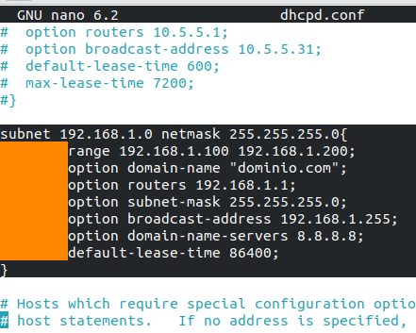nano dhcpd.conf